UI Program (1)

Type: look at 3rd digit of file name.

Character | Type
p | Container
q | Query
b | Browser
w | Viewer
d | Print
v | Processing
n | App Server
j, e | Business Entity
_ | Dialog

Naming:
<Module><Submodule><Type><Naming 3 digits><Running number 2 digits>.(w, p)

Example: s_part00.w

Character | Meaning | Value
s | Module | Stamm (S)
_ | Submodule | -
p | Type | Container
art | Name | art
00 | Running Number | 00

Create Instance
Open RepoClass

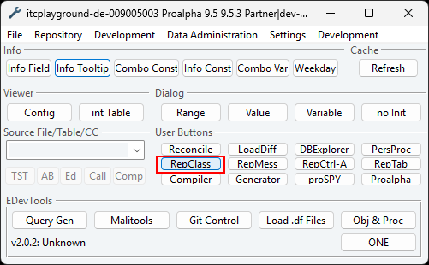

Container
- Reference path from s_part00.w
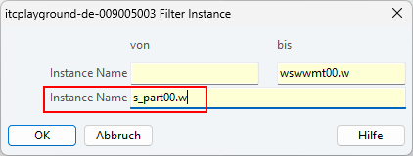

- Right click on “Master Data Maintenance”, then create a new instance.
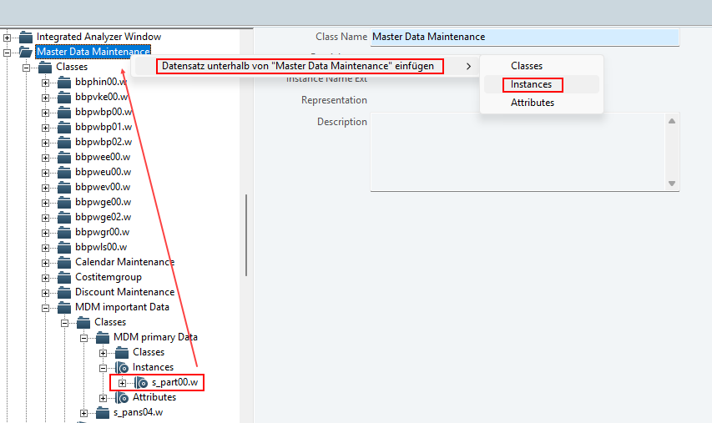

- Fill the instance name, then save.
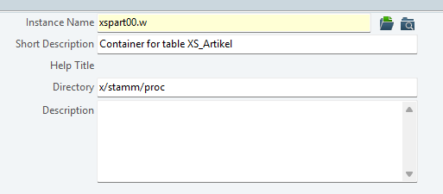

Browser
- Right click on “SmartBrowser”, then create a new instance.
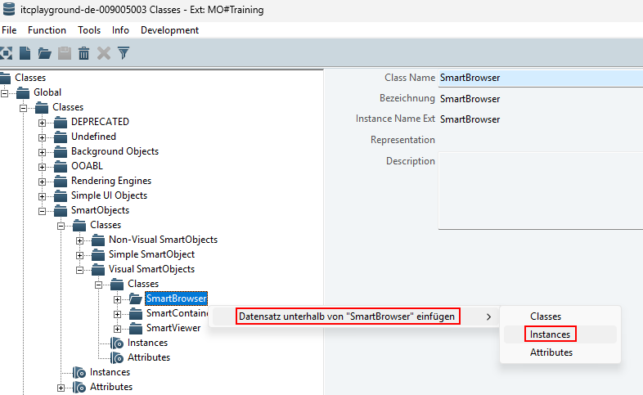

- Fill the instance name, then save.
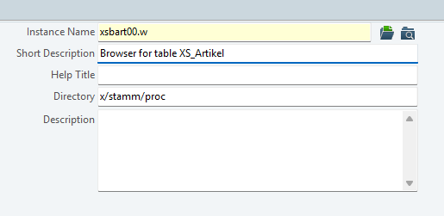

Viewer
- Right click on “SmartViewer”, then create a new instance.
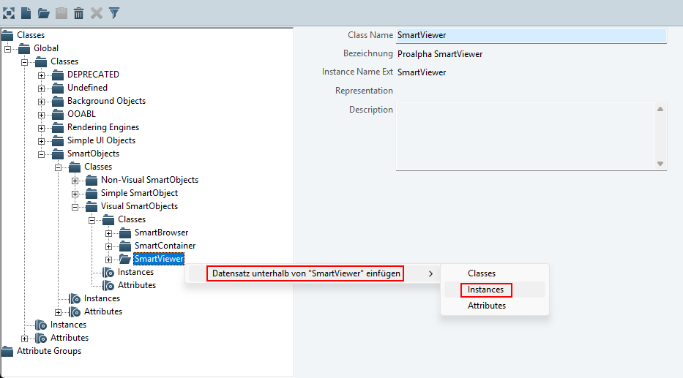

- Fill the instance name, then save.
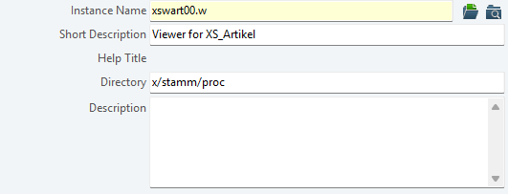

Query
- Reference path from s_qart00.p
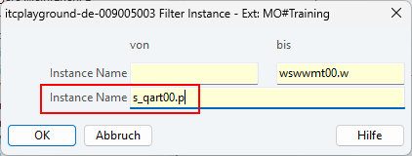

- Right click on “SmartQuery”, then create a new instance.
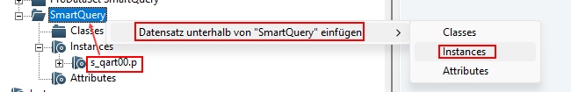

- Fill the instance name, then save.
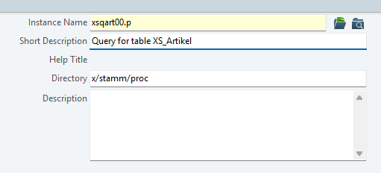

Create Program
Click “new” icon on AppBuilder
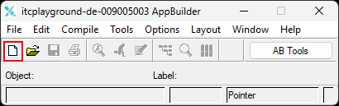

Container
- Select Proalpha SmartWindow then click OK
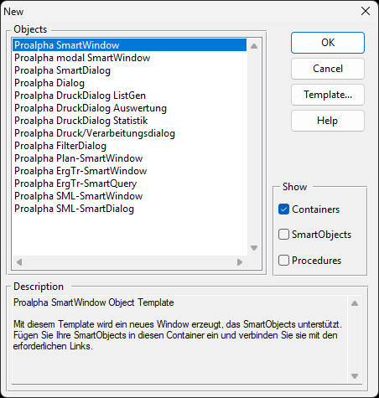

- Fill in your instance name then click OK
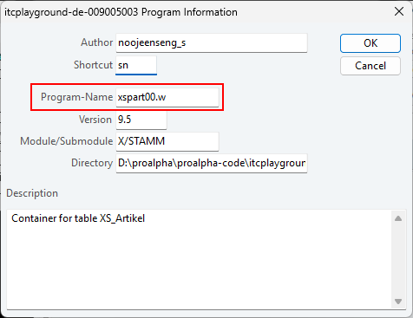
- You can change the title here.
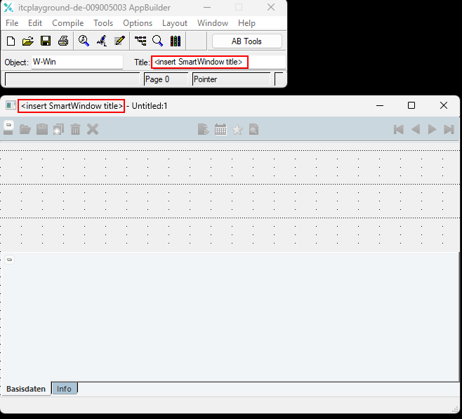

- Choose Continue. Save the flie anyway and click OK
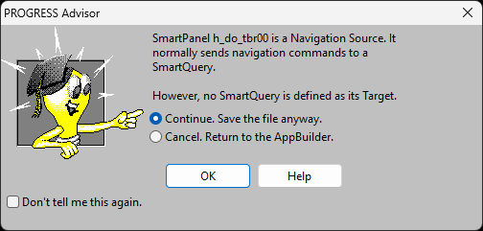

Browser
- Select Proalpha SmartBrowser Wizard then click OK
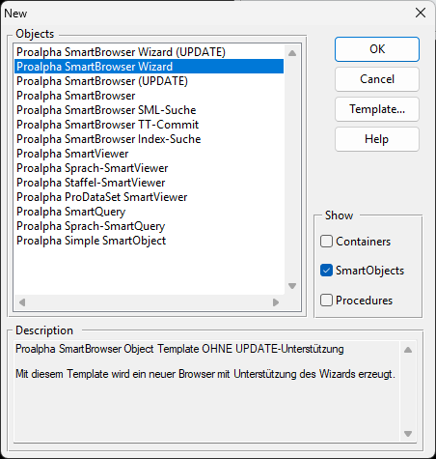

- Fill in your instance name then click OK
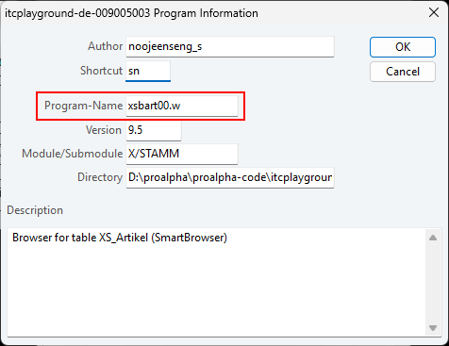

- Skip page 1-2 then Define Query
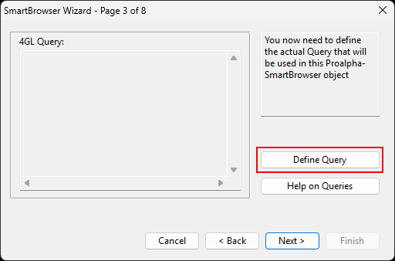
- Find and select the table “XS_Artikel”
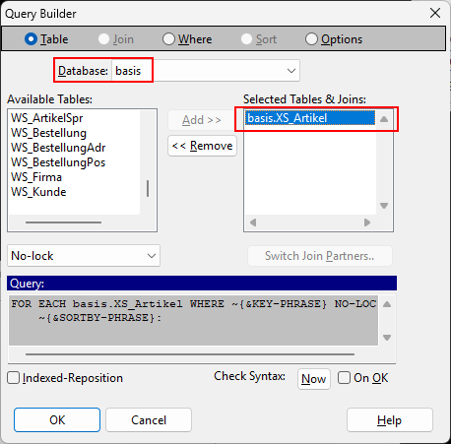

- Click where, choose Firma then click “=”
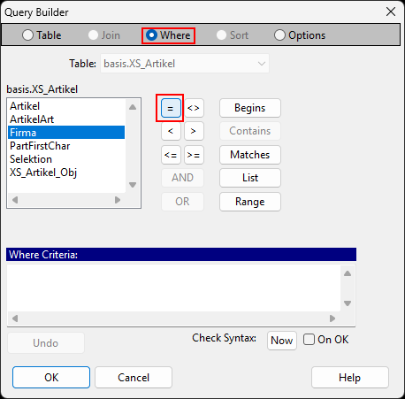

- Click OK with empty value
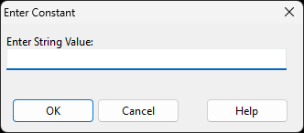

- Fill in the firma (You can get this code from query generator of the table). Then click OK.
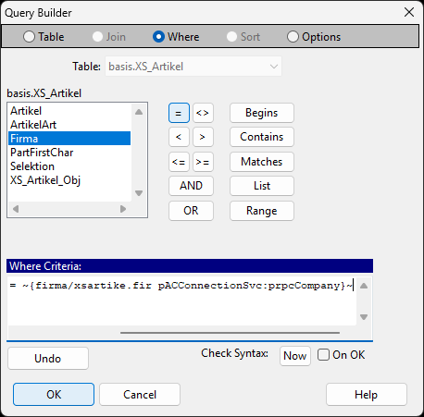
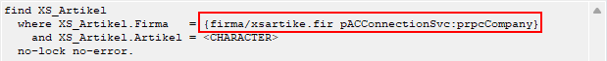

- Next page. Define Sort Cases
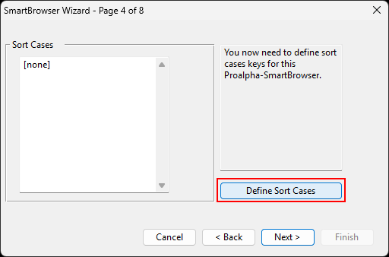

- Click “Quick Insert…”. Select the sort cases.
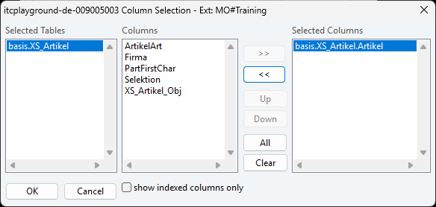

- Click OK
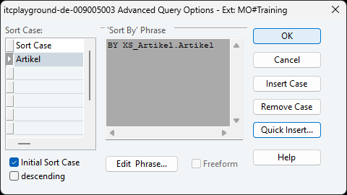
- Next Page. Choose the fields to display.
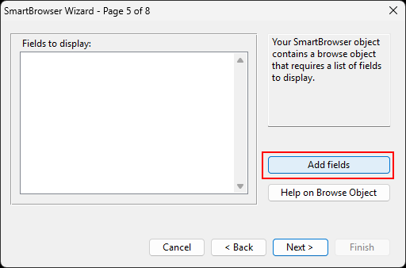
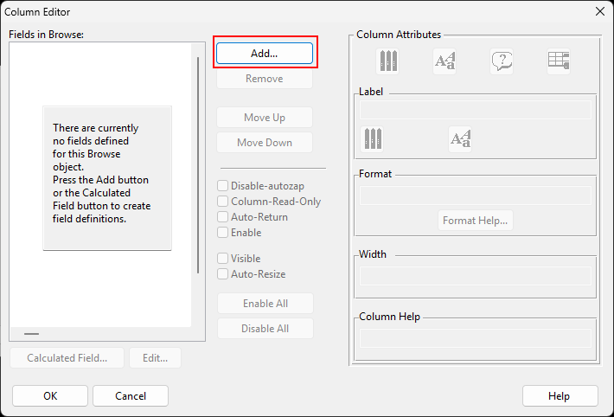
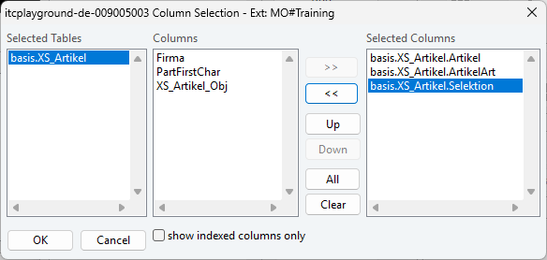

- Check “Enable” for the last field
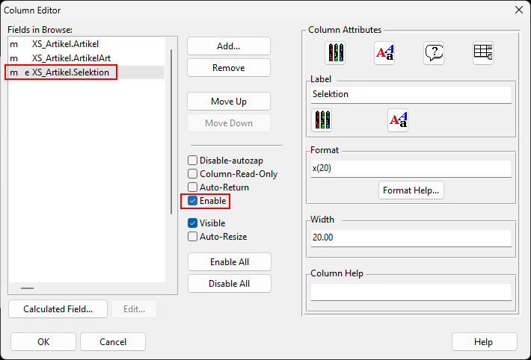

- Next Page. Define Foreign Keys
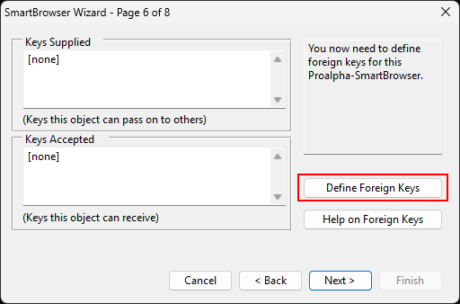

- Click insert SIndex. Then OK.
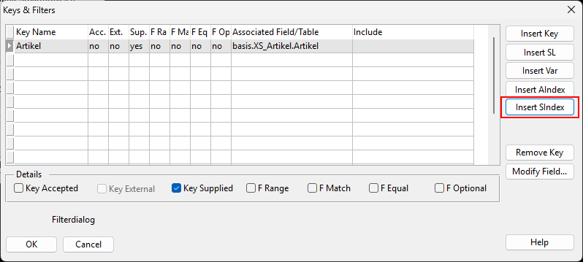

- If this message is displayed. Click OK.
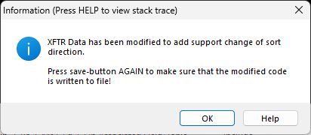

- Update Query
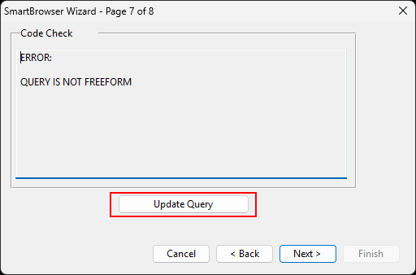

- Click “Freeform Query…”
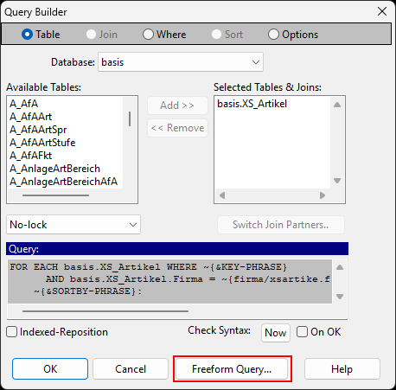

- Choose Freeform. Then OK.
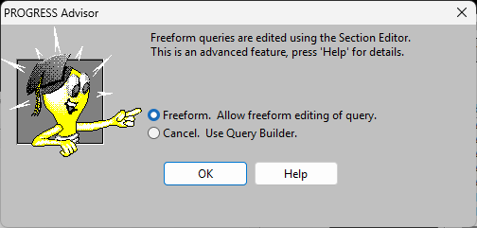

- Select Next until Finish. Then save twice.
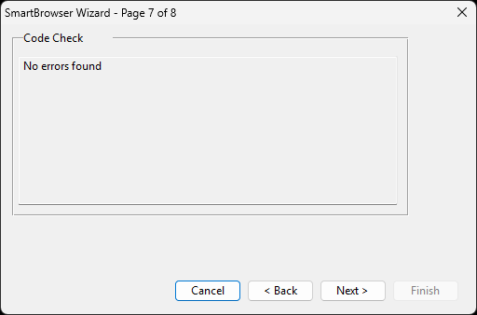
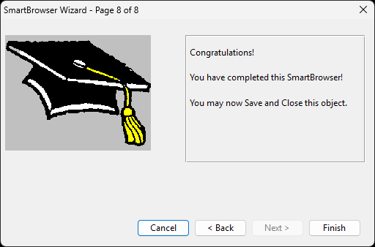

- If this message is displayed, select yes.
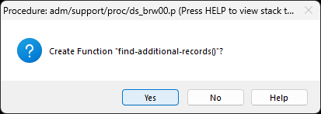

Viewer
- Select Proalpha SmartViewer then click OK
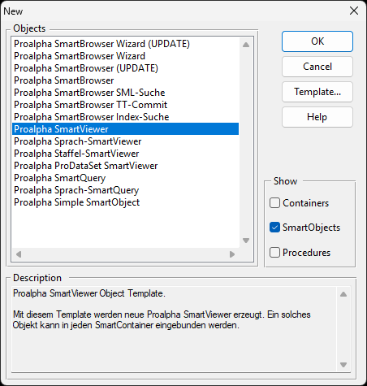

- Fill in your instance name then click OK
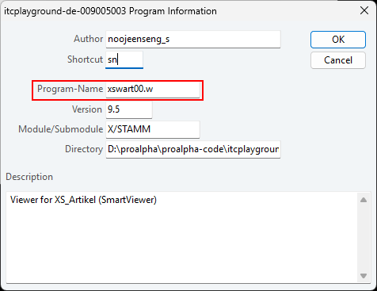

- Select the table “XS_Artikel” then click OK.
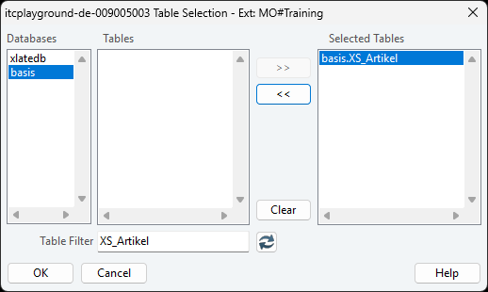

- Select the fields to display then click OK.
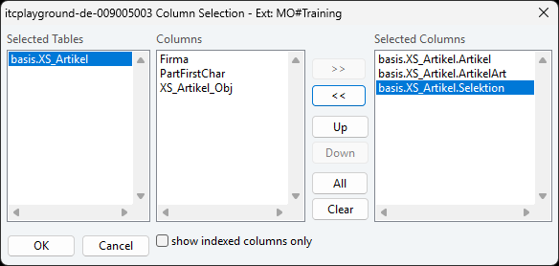

- You would get the selected fields.
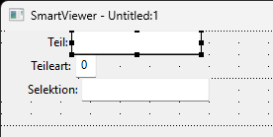

- Double-Click on object, update column to 21 (Standard of Proalpha).
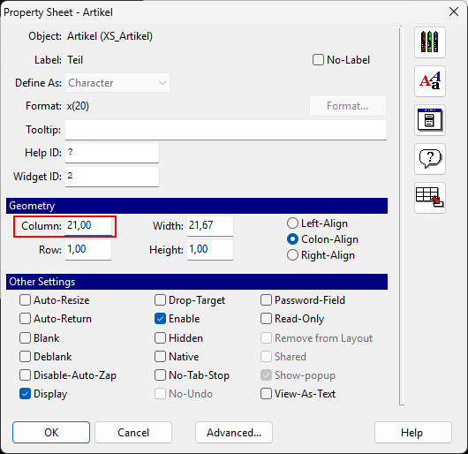

- For key fields, click advanced…
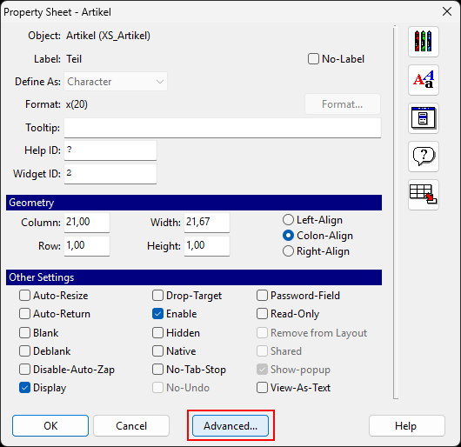

- Enabled 2 checkboxes
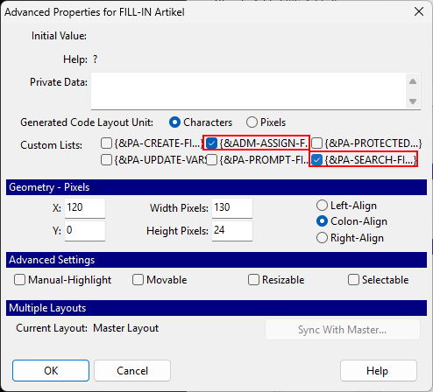

- Hooray! Save it.
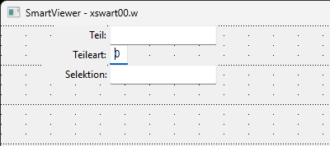

Query
- Select Proalpha SmartQuery then click OK
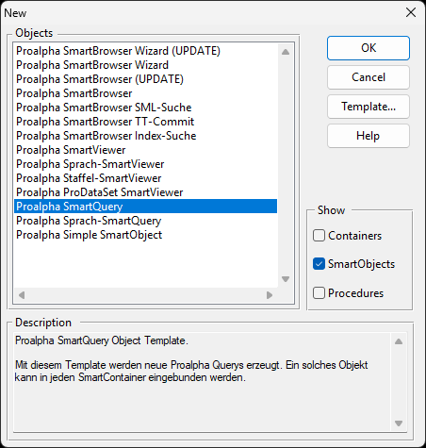

- Fill in your instance name then click OK
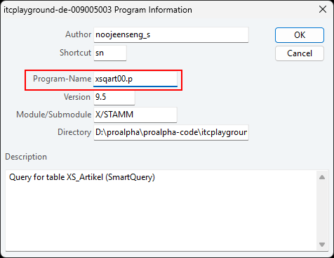

- Skip page 1-2 then Define Query
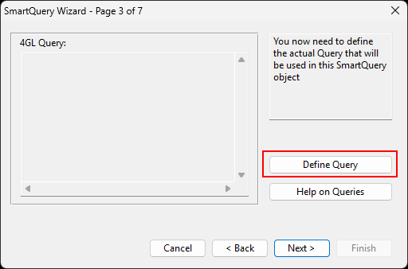

- Find and select the table “XS_Artikel”
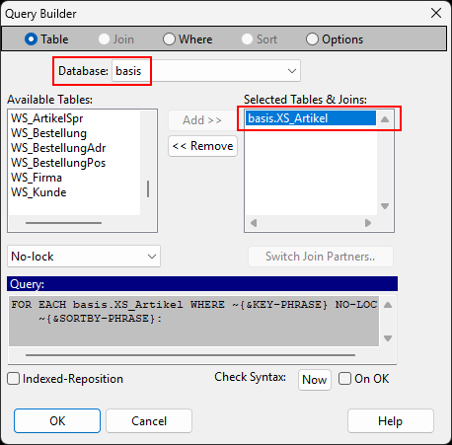

- Click where, choose Firma then click “=”
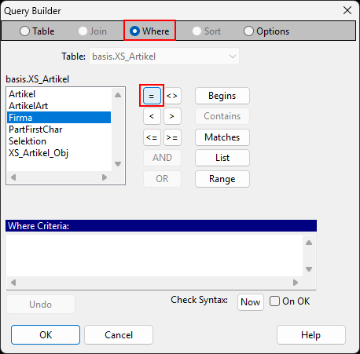

- Click OK with empty value


- Fill in the firma (You can get this code from query generator of the table). Then click OK.
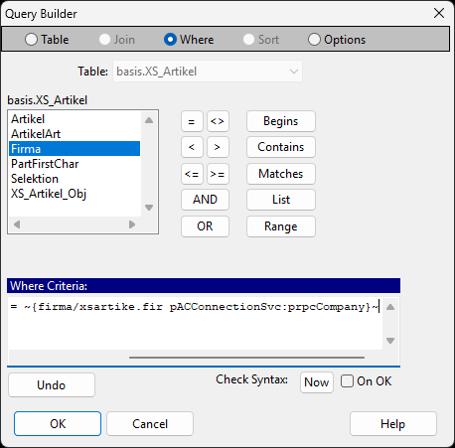


- Next Page. Define Foreign Keys
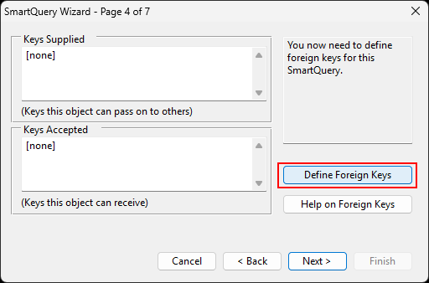

- Click insert SIndex. Then OK.
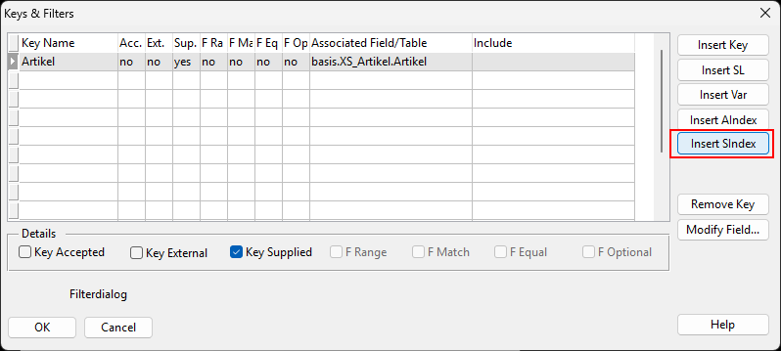

- Next page. Define Sort Cases
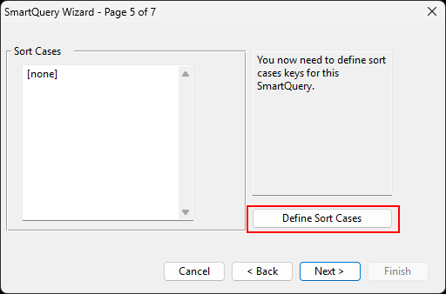

- Click “Quick Insert…”. Select the sort cases.
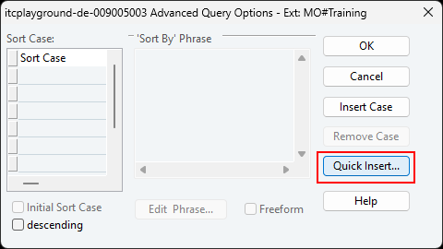
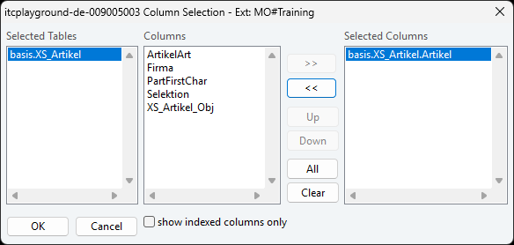

- Click OK


- Hooray! Save it.
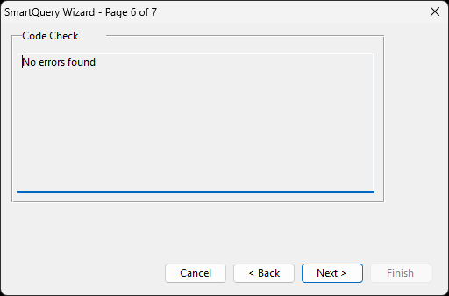
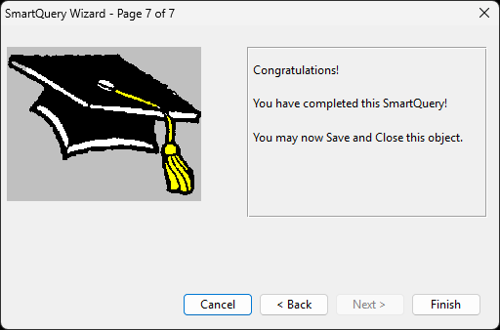

Link programs

Container + Query + Viewer
- Open Container by fill in Source File then click “AB”
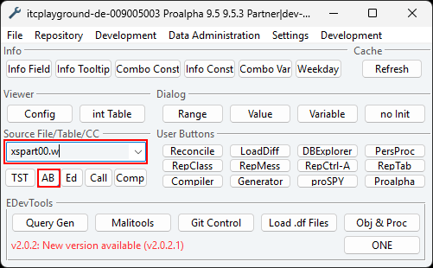
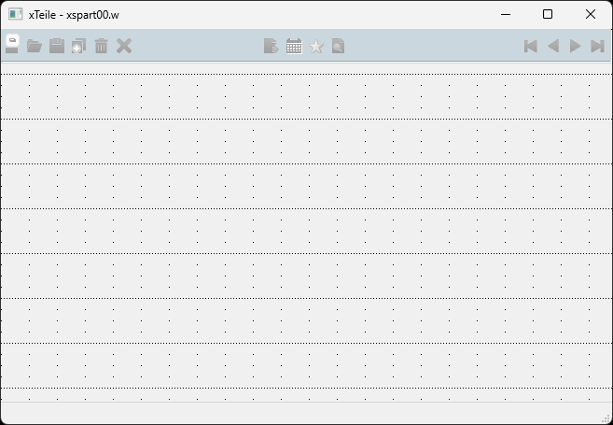

- Add Query to the container
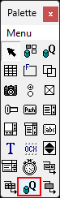

- Click “Browse…” and select the query program.
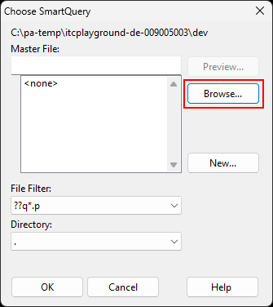
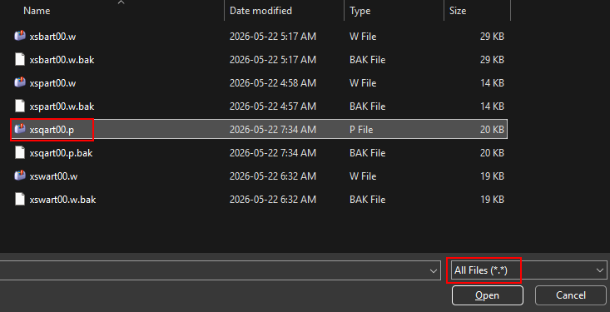

- Paste the query program to the container. Select Add Link then click OK.
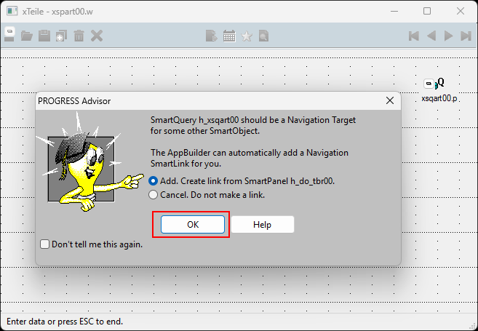

- Add viewer to the container
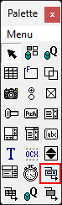

- Click “Browse…” and select the viewer program.
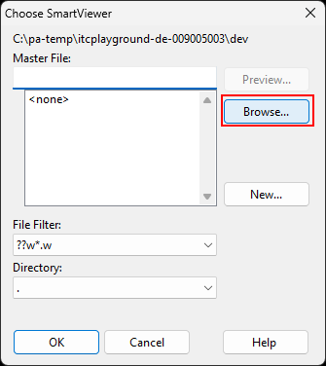

- Paste the viewer program to the container. Select Add Link then click OK.
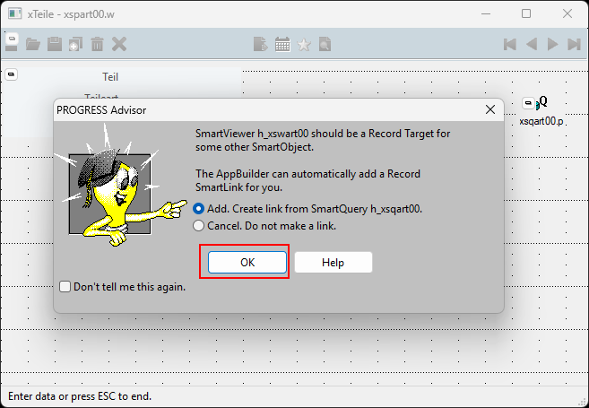

- Save the container.
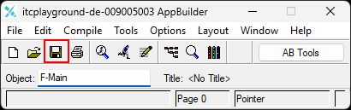

- Check it by click “Call” to open the container program.
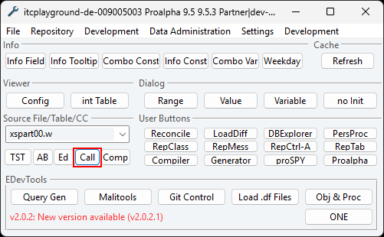

- Hooray!
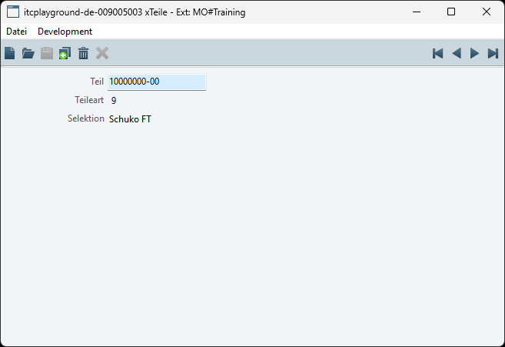

Container + Browser + Viewer
- Open Container by fill in Source File then click “AB”



- Add Browser to the container
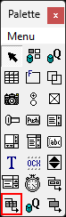

- Click “Browse…” and select the browser program.
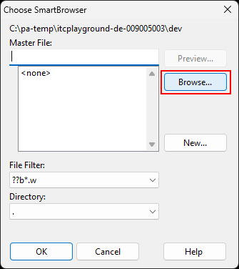

- Paste the browser program to the container.
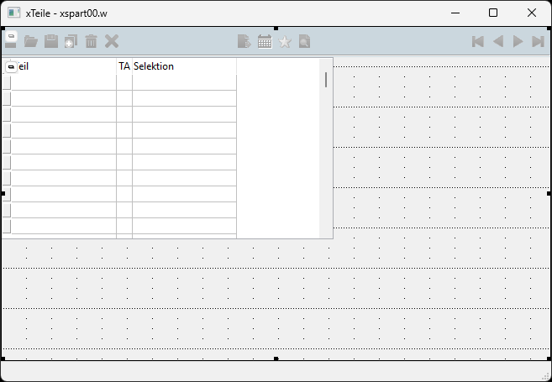

- For viewer same as point 3.1 then save the container.
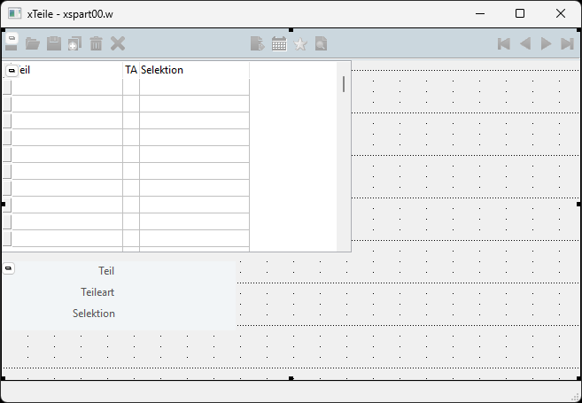

- Hooray!
